Research for bot architecture:

We have:

* Arduino UNO R3
* 2 IR sensors
* 1 L298N H bridge motor driver
* V5 shield
* SG90

Line Following (<https://www.electronicshub.org/>):

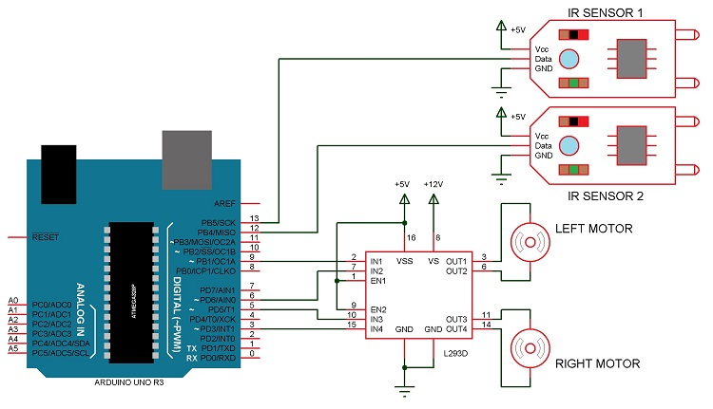

We will follow this and connect IR sensors to D12 & D13

<https://www.electronicshub.org/arduino-line-follower-robot/>

Wifi connecting robot (<https://www.electronicshub.org/>):

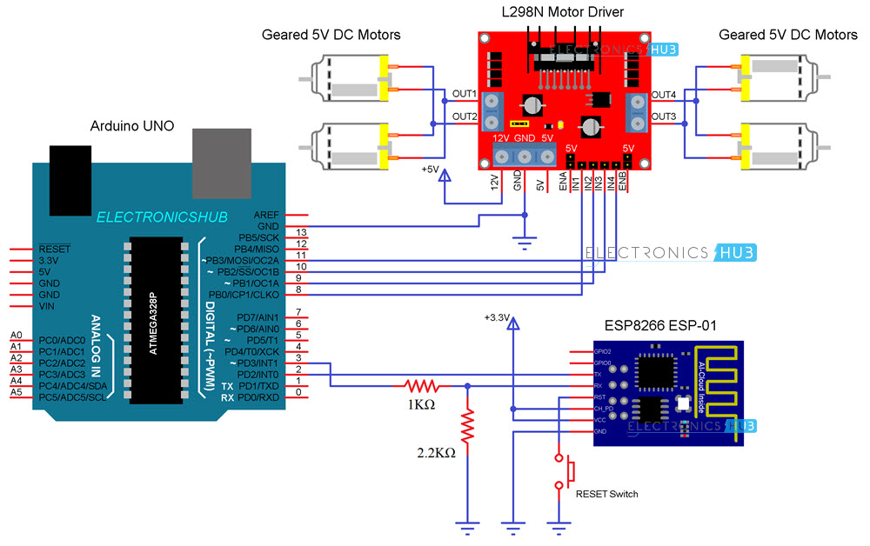

We will follow this and connect the motor (only 2 connections {as only 2 motors}) and ESP chip as shown

<https://www.electronicshub.org/wifi-controlled-robot-esp8266-arduino/>

To make all of this work together we will be using a sensorsheild which just allows for a little more freedom & simplicity in the I/O side of things:

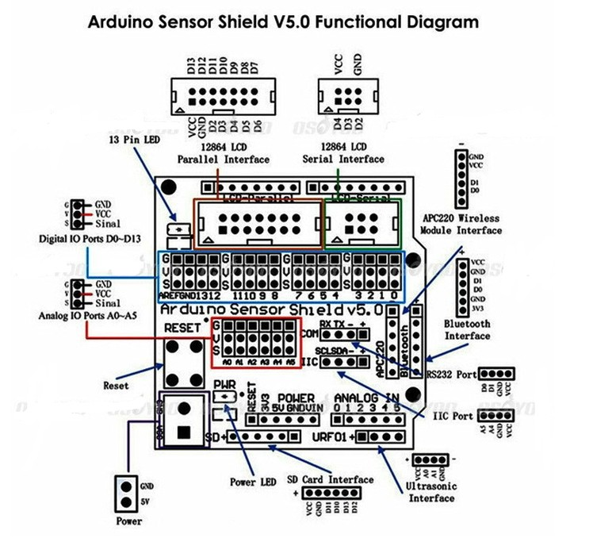

This gives us another interface (URF01) for the US sensor we will be using to avoid collisions

<https://www.electronicshub.org/obstacle-avoiding-robot-arduino/>

Line Following and US sensor eg:

<https://www.youtube.com/watch?v=QKXEycqRphg>

